1.a)
Frequency:100 Hz
Volt:10V peak-to-peak
Rl:1kΩ

Vin & Vout

Frequency:100Hz
Volt:10V peak-to-peak
Rl:1kΩ
C:10 μF
Vin & Vout

Frequency:100Hz
Volt:10 Volt peak-to-peak
Rl:1KΩ
C:1μF
Vin & Vout

 | C:10 μF | C:1 μF
Vout-DC
Fripple
Vpeaktopeak-ripple

2.b)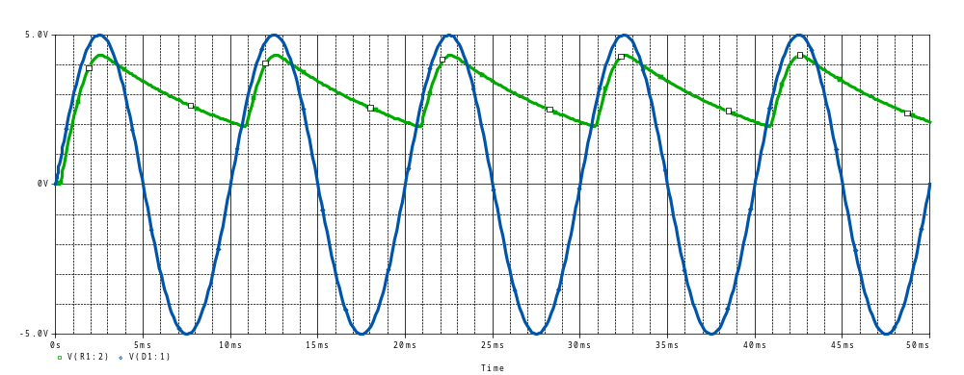
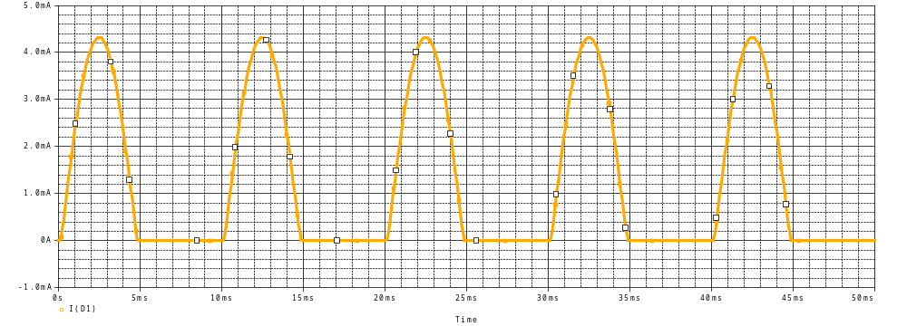
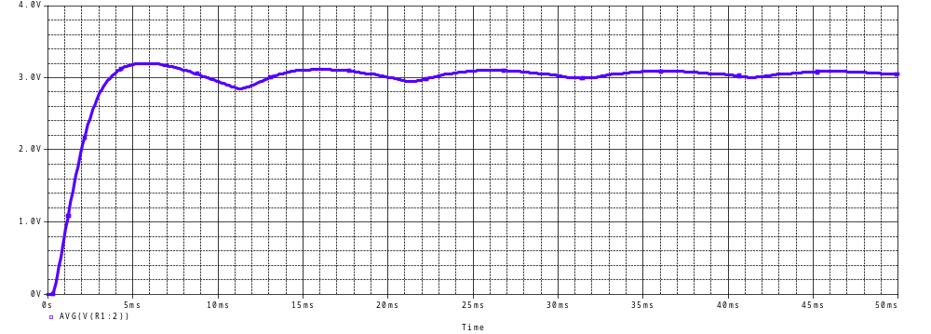
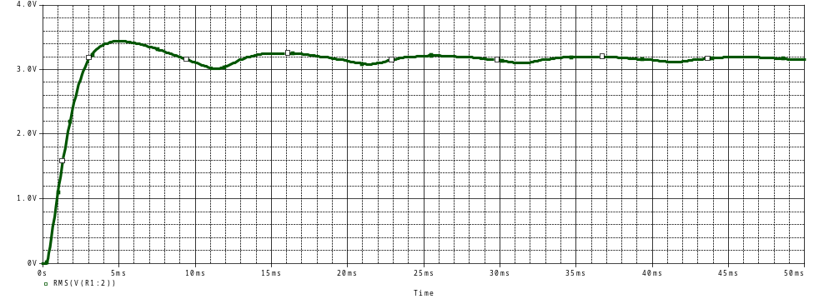

3.a)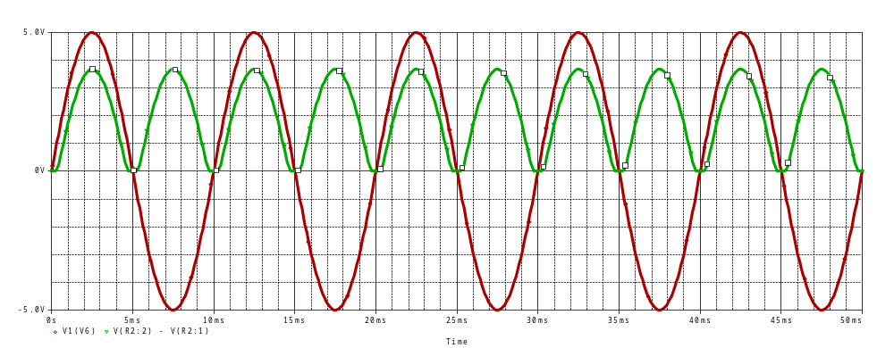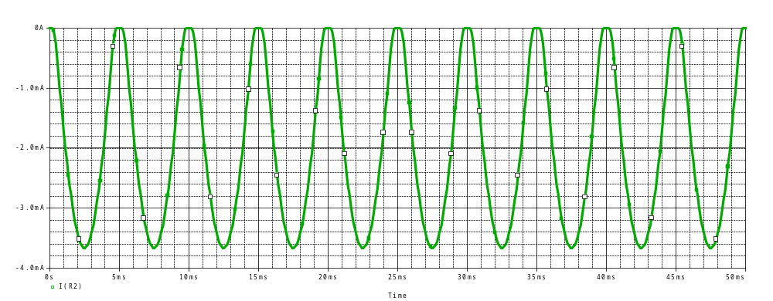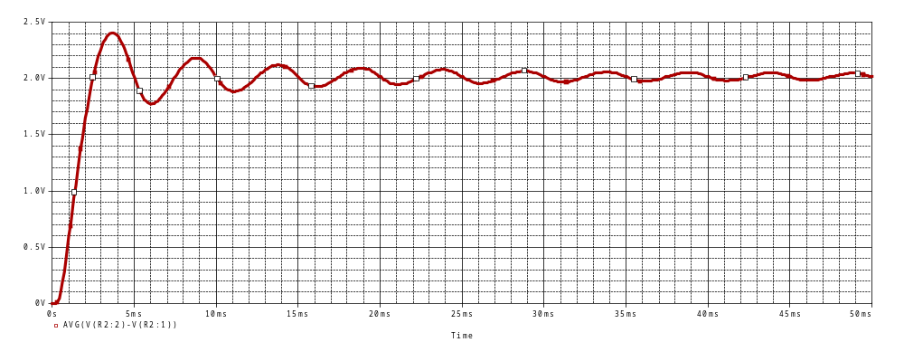
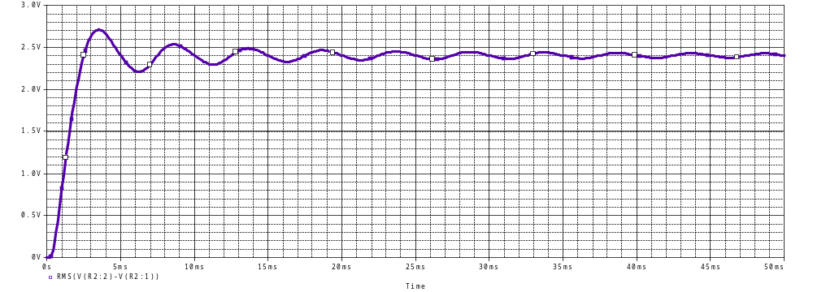

3.b) 